Brilliant NYC Community Meeting

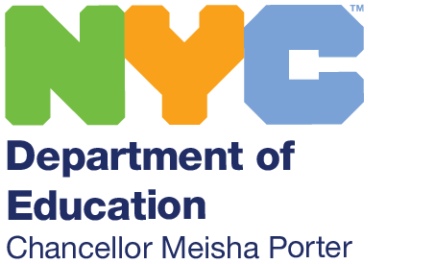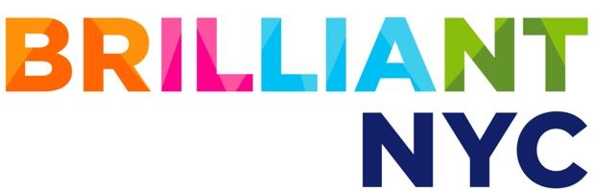  “There are so many students who are gifted, who are talented, who are brilliant." Chancellor Meisha Porter  Brilliant NYC will ensure every student has the opportunity to reach their full potential.  This is an opportunity to hear from families and members of Community School District 21 and is hosted by Superintendent Isabel DiMola.  Join us to discuss how we can co-design your child’s learning experience using the latest educational research.  Please use this link to register:  https://learndoe.org/brilliantnyc/D21/  Learn more at: schools.nyc.gov/brilliantnyc | Tuesday, November 30, 2021  6:00–7:30 PM  Use these to register also:  https://tinyurl.com/BrilliantNYCD21    Translation of the meeting will be available in Spanish, Mandarin and Russian.

